

**Project Report on**

AI in HEALTHCARE (Diagnosis and Treatment Application)

(HEART-RISK CALCULATOR)

INTRODUCTION NAME - MOHAMMED FAIZAN

SECTION - K21QT

REGISTRATION NO - 12115149

GROUP - 1

SUBJECT - INT 404 (AI)

PROJECT REPORT TOPIC - HEART RISK CALCULATOR

SUBJECT TEACHER - AKSHARA MAM

COLLEGE - LOVELY PROFESSIONAL UNIVERSITY

|  |  |  |
| --- | --- | --- |
| Sr. No. | Topics | Page No. |
| 1 | Team Members & Roles and Responsibilities | 3 |
| 2 | Introduction-AI in Healthcare | 4 |
| 3 | Names of AI Software | 5 |
| 4 | Machine Learning Algorithms | 7 |
| 5 | Natural Language Processing | 7 |
| 6 | AI Software in HealthCare (Heart Risk Calculator) | 8 |
| 7 | Future of AI in Health Care | 10 |
| 8 | Conclusion & Result | 11,12 |
| 9 | Acknowledgement | 14 |
| 10 | Conclusion & References | 15,16 |

**TEAM MEMBERS FOR PROJECT ARE:**

|  |  |  |  |  |  |  |  |  |  |  |  |  |  |  |  |  |
| --- | --- | --- | --- | --- | --- | --- | --- | --- | --- | --- | --- | --- | --- | --- | --- | --- |
| |  |  |  | | --- | --- | --- | | **Name** | MOHAMMED FAIZAN | SUJOY DAS | | **Roll no** | 13 | 15 | | **Reg. no.** | 12115149 | 12116211 | | **Section** | K21QT | K21QT | | **Group** | 1 | 1 | |  |

**Roles And Responsibilities :**

1. Module 1: - Role 1: Mohammed Faizan

Responsibilities: 1 Making Pre-Submission and Hard-Copy-Report

2 Requirements & Design Analysis

3 Making Frontend Part (HTML, CSS)

2 Module 2: - Role 2: Sujoy Das

Responsibilities: 1 Making Seminar Report

2 Testing Work

3 Making Backed Part (JavaScript)

**INTRODUCTION**

**AI Software in Healthcare**

AI software is revolutionizing the healthcare industry by automating tedious tasks, providing more accurate diagnoses, and offering personalized treatment plans for patients. This technology is being used in a variety of ways, from detecting diseases earlier to reducing medical errors and improving patient outcomes.

One of the main advantages of AI software in healthcare is its ability to process large amounts of data quickly and accurately. Machine learning algorithms, natural language processing, and predictive analytics are just a few examples of AI technologies used in healthcare. By analysing patient data, AI software can detect patterns and predict outcomes, which can help healthcare providers make more informed decisions about patient care.

AI software is also being used to diagnose diseases more accurately. For example, a study published in the journal Nature Medicine found that an AI system was able to diagnose skin cancer with the same accuracy as a team of dermatologists. Similarly, AI software is being used to diagnose other diseases, such as breast cancer and heart disease, with high levels of accuracy.

In addition to diagnosis, AI software is being used to develop new drugs. By analysing vast amounts of data, AI systems can identify potential drug candidates and predict their efficacy. This can help pharmaceutical companies save time and money in the drug development process.

AI software is also being used to automate administrative tasks, such as data entry and record-keeping. By automating these tasks, healthcare providers can save time and reduce the risk of errors.

In conclusion, AI software is transforming the healthcare industry by providing more accurate diagnoses, developing new drugs, automating administrative tasks, and facilitating telehealth consultations. As AI technology continues to evolve, we can expect to see even more applications of this technology in healthcare in the years to come.

## Names of AI Software

There are many types of AI software used in healthcare, such as IBM Watson, Google DeepMind, and Microsoft Azure. These technologies can be used to detect diseases earlier, reduce medical errors, and improve patient outcomes.

Other AI software used in healthcare includes Nuance Dragon Medical, NVIDIA Clara, and GE Healthcare Edison etc. These technologies can be used to automate tedious tasks, such as data entry, and to make more accurate diagnoses.

* + IBM Watson
  + Google DeepMind
  + Microsoft Azure
  + Nuance Dragon Medical
  + NVIDIA Clara
  + GE Healthcare Edison
  + Cogito
  + UiPath
  + Atomwise
  + Zebra Medical Vision
  + Ada Health
  + Babylon Health
* IBM Watson: Watson is a cognitive computing system developed by IBM that can analyze complex data and generate insights. In healthcare, Watson can be used to analyze patient data and medical records to provide doctors with personalized treatment options.
* Google DeepMind: DeepMind is an AI research company owned by Google. In healthcare, DeepMind has developed an AI system that can diagnose eye diseases, such as macular degeneration and diabetic retinopathy, using retinal scans.
* Microsoft Azure: Azure is a cloud computing platform developed by Microsoft. In healthcare, Azure can be used to store and analyze large amounts of patient data, allowing doctors to make more informed decisions.
* Nuance Dragon Medical: Dragon Medical is a speech recognition software that allows doctors to dictate patient notes, saving them time and reducing the risk of errors.
* NVIDIA Clara: Clara is an AI platform developed by NVIDIA that can be used in medical imaging to assist with tasks such as segmentation and registration.
* GE Healthcare Edison: Edison is an AI platform developed by GE Healthcare that can be used to analyze medical images, such as CT scans and X-rays, to help doctors make more accurate diagnoses.
* Cogito: Cogito is an AI-powered behavioral analytics platform that uses machine learning to analyze voice conversations and provide real-time insights into patient engagement during telehealth consultations.
* UiPath: UiPath is an AI-powered robotic process automation platform that can automate repetitive tasks such as scheduling appointments, processing claims, and managing EHRs.
* Atomwise: Atomwise is an AI-powered drug discovery platform that uses deep learning to predict how molecules will interact with each other. This enables researchers to develop new drugs more quickly and efficiently than traditional drug discovery methods, potentially saving lives and improving patient outcomes.
* Zebra Medical Vision: Zebra Medical Vision is an AI-powered medical imaging analysis platform that uses machine learning to identify potential anomalies or diseases in medical images, including X-rays and CT scans.
* Ada Health: Ada Health is an AI-powered health assessment app that uses machine learning to analyze symptoms and provide personalized health recommendations to users.
* Babylon Health: Babylon Health is an AI-powered telemedicine platform that enables patients to consult with doctors remotely, using natural language processing to facilitate the conversation and assist with diagnoses.

Overall, AI software applications in healthcare have the potential to transform the industry by improving patient outcomes, reducing costs, and increasing efficiency. As AI technology continues to evolve, we can expect to see even more innovative applications emerging in the healthcare industry.

## Machine Learning Algorithms

Machine learning algorithms are used to analyse large amounts of data and identify patterns. They can be used to detect diseases earlier, reduce medical errors, and improve patient outcomes. Machine learning algorithms can also be used to automate tedious tasks, such as data entry.

Machine learning algorithms can also be used to provide personalized treatment plans for patients. They can also be used to streamline administrative tasks, such as billing and scheduling. Machine learning algorithms can also be used to provide personalized patient care, such as providing reminders for appointments and medication refills.

## Natural Language Processing

Natural language processing (NLP) is a type of AI software used to analyse and interpret human language. It can be used to detect diseases earlier, reduce medical errors, and improve patient outcomes. NLP can also be used to automate tedious tasks, such as data entry.

NLP can also be used to provide personalized treatment plans for patients. It can also be used to streamline administrative tasks, such as billing and scheduling. NLP can also be used to provide personalized patient care, such as providing reminders for appointments and medication refills.

**AI Software in Healthcare (Heart Risk Calculator)**

Artificial intelligence (AI) is revolutionizing the healthcare industry. From drug discovery to patient care, AI is being used to improve efficiency, accuracy, and outcomes. One area where AI is making a significant impact is in the development of heart risk calculators. These tools use algorithms to analyse a range of patient data and determine an individual's risk of developing heart disease. While heart risk calculators offer numerous benefits, they also have some limitations that need to be considered.

Heart disease is a leading cause of death globally, with millions of people dying every year. The key to preventing heart disease is identifying and managing the risk factors early. To achieve this, healthcare providers have traditionally used heart risk calculators to determine an individual's risk of developing heart disease. However, traditional risk calculators have limitations in their ability to account for all possible risk factors. This is where artificial intelligence (AI) comes in.

AI-powered heart risk calculators are designed to provide a more accurate assessment of an individual's risk of developing heart disease by analysing a range of patient data using complex algorithms. These calculators can consider a wide range of variables, including age, gender, blood pressure, cholesterol levels, family history, lifestyle factors, and genetics, among others. By analysing this information, AI-powered heart risk calculators can provide a more comprehensive and personalized risk assessment than traditional calculators.

**Advantages of Heart Risk Calculator using AI**

**Increased accuracy:** Heart risk calculators that use AI algorithms can take into account a range of variables that traditional risk calculators cannot. These variables include factors such as family history, lifestyle, and genetics. By analysing this information, AI-powered heart risk calculators can provide more accurate risk assessments.

**Personalized treatment:** Because AI-powered heart risk calculators can provide more detailed risk assessments, doctors can create personalized treatment plans that take into account a patient's unique risk factors. This can help improve patient outcomes and reduce the likelihood of future heart problems.

**Efficiency:** AI-powered heart risk calculators can analyse patient data more quickly and accurately than traditional risk calculators. This can help doctors make faster and more informed decisions, leading to better patient care.

**Cost-effective:** By reducing the need for expensive and time-consuming tests, AI-powered heart risk calculators can save money and resources for both patients and healthcare providers.

**Disadvantages of Heart Risk Calculator using AI**

**Limited data**: AI-powered heart risk calculators rely on patient data to provide risk assessments. However, if a patient's data is incomplete or inaccurate, the risk assessment may not be reliable.

**Bias:** AI algorithms can be biased if they are not properly designed and trained. This can result in inaccurate risk assessments, especially for patients from certain demographic groups.

**Limited human input:** AI-powered heart risk calculators rely solely on algorithms to provide risk assessments. While this can be efficient, it also means that there is limited opportunity for human input or oversight.

**FUTURE OF AI IN HEALTH CARE**

Artificial intelligence (AI) has the potential to revolutionize the healthcare industry, transforming the way medical professionals diagnose, treat, and manage patient care. In the coming years, AI will continue to play a vital role in healthcare, offering significant benefits to both medical professionals and patients.

One area in which AI is already making a significant impact is in medical diagnosis. AI algorithms are being developed to analyze medical images, such as X-rays and CT scans, to identify anomalies and diagnose conditions with a high degree of accuracy. These algorithms can analyze vast amounts of data in seconds, potentially reducing the time it takes to diagnose and treat patients.

AI is also being used to improve patient outcomes by offering personalized treatment plans. By analyzing large amounts of patient data, AI algorithms can identify patterns and risk factors, helping medical professionals to tailor treatment plans that are specific to each patient's needs. This could lead to more effective treatment options and better health outcomes for patients.

Another area where AI is set to make a significant impact is in medical research. With the vast amounts of data generated by medical research, AI algorithms can help researchers to identify patterns and relationships that may not be immediately apparent to the human eye. This could lead to new insights into the underlying causes of diseases, as well as the development of new treatments and cures.

Despite the many benefits of AI in healthcare, there are also some concerns about its use. One major concern is the potential for AI algorithms to be biased or inaccurate, leading to misdiagnosis or inappropriate treatment. There are also concerns about data privacy and security, with the vast amounts of medical data generated by AI algorithms potentially putting patient confidentiality at risk.

In conclusion, the future of AI in healthcare is bright, with the potential to revolutionize the way medical professionals diagnose, treat, and manage patient care. As AI technology continues to evolve, it is likely that we will see even more significant benefits in the coming years. However, it is important to address the potential concerns associated with AI and healthcare to ensure that these technologies are used safely and effectively.

**CONCLUSION**

Heart risk calculators using AI algorithms have numerous benefits, including increased accuracy, personalized treatment, efficiency, and cost-effectiveness. However, there are also some limitations that need to be considered, such as limited data, bias, and limited human input. Healthcare providers must weigh these pros and cons when deciding whether to use AI-powered heart risk calculators in their practice. While AI technology has the potential to revolutionize healthcare, it must be used responsibly and ethically to ensure the best possible outcomes for patients.

In conclusion, AI-powered heart risk calculators have the potential to revolutionize the prevention and management of heart disease. By providing more accurate and personalized risk assessments, these calculators can help healthcare providers identify and manage risk factors early, ultimately leading to improved health outcomes for patients. Nevertheless, it is important to ensure that the algorithms are properly designed and tested to avoid bias and that the data used to train the algorithms is of high quality.

**RESULT**

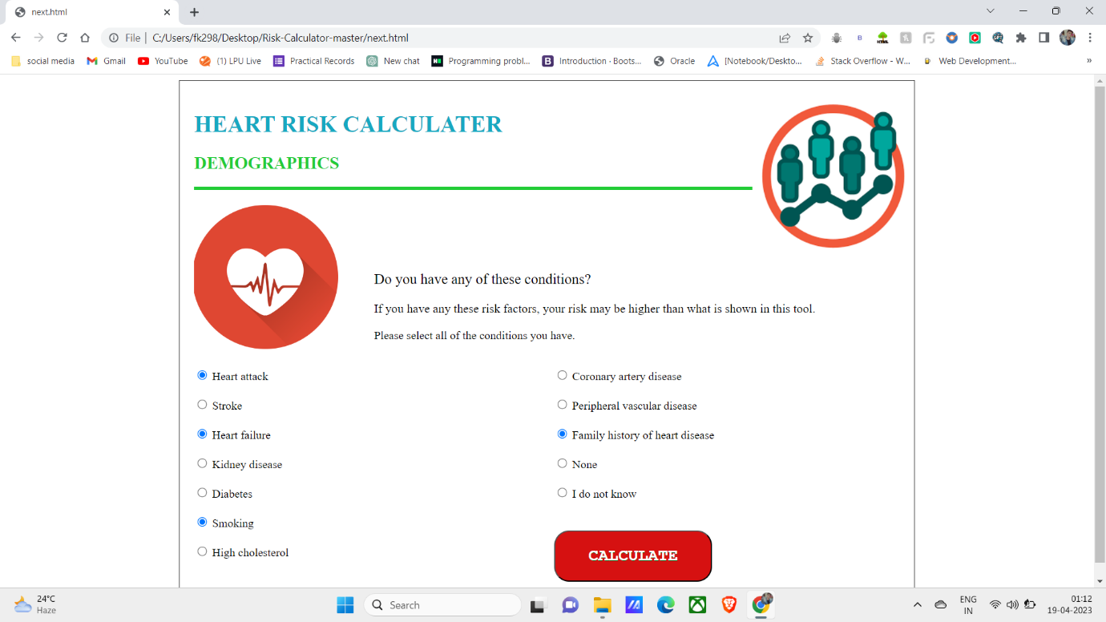

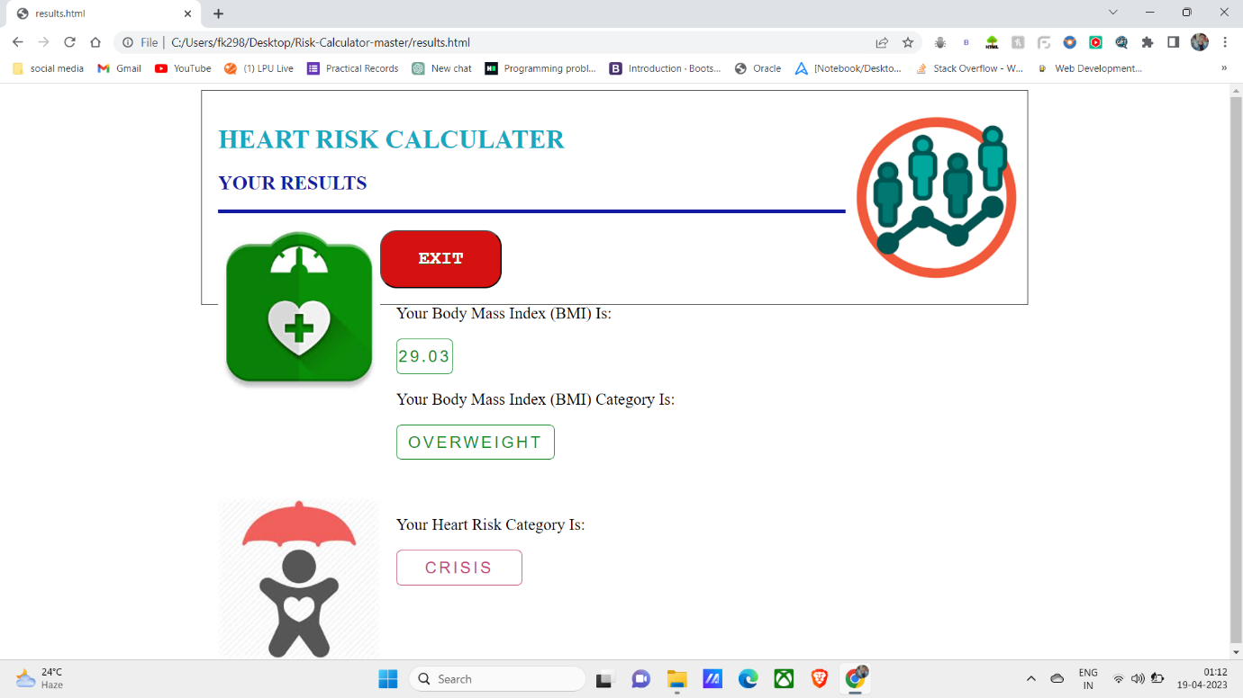

**ACKNOWLEDGEMENT**

Firstly, I would like to express my special thanks of gratitude to my AI teacher.

“Akshara Rana Mam” who gave me the golden Opportunity to do this wonderful.

project on the topic of “AI IN HEALTHCARE(Heart Risk Calculator)”, which

also helped me in doing a lot of research and I come to know about so many new

things and for their guidance and support I am able to complete my Project.

Secondly, I would also like to thank friends who helped me a lot in finishing.

project within the limited time.

**CONCLUSION**

Here I have come to the end of my project on the topic of “Heart Risk Calculator”.

I would like to share my experience while doing this project.

I learnt many new things about Heart Risk Calculator, and it was a wonderful learning experience for me while working on this project.

This Project took me through the various phases of project development and gave me real insight into the world of programming and the joy of work and the thrill involved while tackling the various problems and challenges gave me a feel of developer’s industry.

This project has developed my thinking skills and make more interest in this subject. This Project gave me real insight in the world of Programming. While doing this project I enjoy very much.

A special thanks to my AI teacher “Akshara Rana Mam” for giving this Golden Opportunity to do this project. It was a wonderful and learning experience for me while working on this project.

Date: Name:

18/04/2023 Mohammed Faizan

Sujoy Das

**REFRENCES**

* [www.google.com](http://www.google.com)
* <https://www.mayoclinichealthsystem.org/locations/cannon-falls/services-and-treatments/cardiology/heart-disease-risk-calculator>
* <https://www.youtube.com/results?search_query=heart+risk+calculator+project>
* <https://www.wikipedia.org/>